**VISVESVARAYA TECHNOLOGICAL UNIVERSITY**

"Jnana Sangama", Belagavi: 590 014, Karnataka.

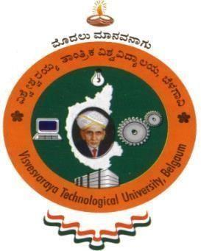

A Project Synopsis on

“**User Interest Based Social Media Data Retrieval System**”

Submitted in partial fulfillment for the award of degree of

Bachelor of Engineering

In

Computer Science & Engineering

**Submitted by**

# ANUDEEP BABU K (3SL19CS006)

# BASANA GOWDA (3SL19CS011)

# RAGHAVENDRA D (3SL19CS035)

# VINODKUMAR SANKRANTHI (3SL19CS055)

**Under the guidance**

**PROF. SURESH PATEL**



**DEPARTMENT OF COMPUTER SCIENCE & ENGINEERING**

**H.K.E Society’s S.L.N. COLLEGE OF ENGINEERING**

**(Affiliated to VTU - Belagavi, Affiliated to AICTE – New Delhi, Accredited by NAAC) Y-Camp, Raichur-584 135, Karnataka**

**2022-2023**

**VISVESVARAYA TECHNOLOGICAL UNIVERSITY**

"Jnana Sangama", Belagavi: 590 014, Karnataka.

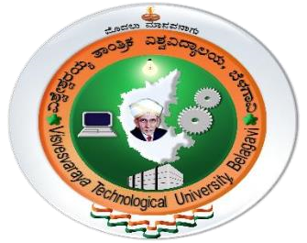

**H.K.E Society’s S.L.N. COLLEGE OF ENGINEERING**

**DEPARTMENT OF COMPUTER SCIENCE & ENGINEERING**



**CERTIFICATE**

A project synopsis on topic “**User Interest Based Social Media Data Retrieval System**” certified that has been successfully submitted at H.K.E Society’s S.L.N. COLLEGE OF ENGINEERING RAICHUR by ANUDEEP BABU K (3SL19CS006), BASANA GOWDA (3SL19CS011), RAGHAVENDRA D (3SL19CS035), VINODKUMAR SANKRANTHI (3SL19CS055) members of the VII-semester of Bachelor of Engineering in Computer Science & Engineering of Visvesvaraya Technological University, 2022 - 2023. It is certified that all corrections/suggestions indicate for Internal Evaluation have been incorporated in the synopsis deposited in the department. The project synopsis has been approved as it satisfies the academic requirements in respect of work for the said degree.

**Signature of Guide Signature of Coordinator Signature of HOD**

**Prof.Suresh Patel Prof.Sujatha J Prof.Sumangala Itagi**